Pegasus Imaging Corporation
32-Bit Imaging Development Kit
PICTools™ Version 2.0

Minerva Sample Program

February 16, 1997
Table of Contents

1. Overview
2. Minerva User Interface
2.1 Menu Bar
2.2 Popup Menu
2.3 Grayed Menu Items
2.4 Dialog Boxes
2.5 Image Windows
3. Modules
3.1 MINERVA.C - Initialization and Exit
3.2 MFRAME.C - MDI Frame Window
3.3 MCHILD.C - MDI Child Windows
3.4 MMENU.C - Menu Item Commands
3.5 MOPEN.C - File/Open
3.6 MSAVE.C - File/Save and File/Save As
3.7 MERROR.C - Error Message Boxes
3.8 MDLG.C - Dialog Box Handling
3.9 MCTRL.C - Dialog Box Control Handling
3.10 MMRU.C - MRU File List Maintenance
3.11 MMISC.C - Queue Handling and Miscellaneous
3.12 MABOUT.C - Help/About
3.13 MOBMP.C - Default Windows Bitmap File/Open
4. Open Opcode Entry Points
5. Save Opcode Entry Points
6. Transform Opcode Entry Point
7. Tools Opcode Entry Points
8. Open Options by Opcode
9. Save Options by Opcode
10. Transform Options by Opcode
11. Tools Options by Opcode

1. Overview
Minerva is a sample application with source code which is included with PICTools Development Kits (devkits). It has the following purposes in order of importance:
- To demonstrate all PICTools technologies, their features and performance benefits;
- To serve as sample code demonstrating how to write code to use all PICTools technologies;
- To be structured so that it’s easy to add new PICTools technologies; and
- To be structured, coded and commented in a clear and expository manner.
Minerva is a Windows application written in C. Project files are included to create Minerva for 16-bit Windows 3.x using Microsoft Visual C++ version 1.52 or Borland C version 4.5 and to create Minerva for 32-bit Windows ’95/Windows NT using Microsoft Visual C++ version 4.2 or Borland C version 4.5.
Minerva is a simple Windows MDI application. An image is opened into a window, possibly after being decompressed. The image is viewed in the window, is possibly transformed (rotated, zoomed, etc.), and is ultimately discarded or saved, possibly after being compressed or translated to a different format. Supported image formats for input and for output depend upon which devkits are installed. Supported transformations on an opened image depend upon the image type and also depend upon which devkits are installed. Default options, specific to each image format, for input, output and transformation are stored in a MINERVA.INI file. After each image has been opened, some applicable options can be changed for that image.
In the following, some references to PIC technologies or to a particular PIC technology refer to opcodes. An implementation of a PIC technology is packaged into a single opcode DLL. For example, the sequential JPEG expand technology is contained in an opcode DLL named PICN1120.DLL (PIC, NT-format, opcode 11, version 20).

2. Minerva User Interface

2.1 Menu Bar
The Minerva menu bar is:

File Transform Tools Window Help
Open Zoom/Halftone Make Palette Cascade Contents
Close Rotate Tile Horizontal About
Save Tile Vertical
Save As Arrange Icons
Properties Close All
Image Options
Default Options
Open
Save
Transform
Tools
Exit

2.2 Popup Menu
Right clicking on an image window pops up this menu:

New Window
Close
Save
Save As…
Properties…
Image Options…
Transform
Zoom/Halftone
Rotate

2.3 Grayed Menu Items
If no image window is open, then menu selections which can only apply to an open window (e.g., File/Close) are grayed. If there are no image options according to the image type in the active image window, then File/Image Options is grayed. If the image has not been transformed, then File/Save is grayed. If the Zoom/Halftone opcode DLL is not available, then Transform/Zoom/Halftone is grayed. If the Rotate opcode DLL is not available, then Transform/Rotate is grayed. If the Color Reduction opcode DLL is not available, then Tools/Make Palette is grayed. If an opcode DLL is not available, then the corresponding menu item cascaded under File/Default Options/Open, Save, Transform or Tools is grayed.
File/Open and File/Save As bring up the corresponding common file dialogs. File/Open creates a list of file name filter options based on the available open opcode DLL’s. File/Save As creates a list of file name filter options based on the available save opcode DLL’s.

2.4 Dialog Boxes
Each open image opcode implements an image properties dialog. All open image opcodes, except the built-in .BMP image loader, implement an image options dialog. A default options dialog for each open image opcode is identical to the image options dialog with mildly different processing rules.
Each save, transform and tools opcode implements an options dialog. This dialog appears after the corresponding menu item is selected. The save options dialog appears after the File/Save As common file dialog when the save opcode’s file name filter is selected. A default options dialog for each opcode is identical to the opcode options dialog with mildly different processing rules.
The Help/About dialog reads the version resource to derive the Minerva name, description, copyright and version. It uses conditional compilation to derive the compiler used, target environment and whether the compilation was for debug or release. It builds and displays a list of available opcodes.

2.5 Image Windows
Image windows are displayed with horizontal and/or vertical scroll bars if the image is larger than the window. If the initial window would be larger than the image, it is shrunk to the size of the image. The image window cannot be sized larger than the image except when the window is maximized. A maximized image window, if larger than the image, presents the image centered in the window with a 3-d border around the image.

3. Modules
Some of the Minerva modules perform processing which is independent of the opcodes. The other modules, MOBMP.C, MO*.C (but not MOPEN.C), MS*.C (but not MSAVE.C), MX*.C and MT*.C are specific to individual opcodes.
Opcode-independent modules:
 | Source File | Purpose
 | MINERVA.C | Initialization and exit
 | MFRAME.C | MDI frame window
 | MCHILD.C | MDI child windows
 | MMENU.C | Menu item commands
 | MOPEN.C | File/Open
 | MSAVE.C | File/Save and File/Save As
 | MERROR.C | Error message boxes
 | MDLG.C | Dialog box functions
 | MCTRL.C | Dialog box control functions
 | MMRU.C | MRU file list maintenance
 | MMISC.C | Queue handling and miscellaneous
 | MABOUT.C | Help/About
Opcode-specific modules:
 | Source File | Purpose
 | MOBMP.C | Default Windows Bitmap File/Open
 | MO*.C | File/Open opcodes
 | MS*.C | File/Save opcodes
 | MX*.C | Transform (xform) opcodes
 | MT*.C | Tool opcodes
Particularly interesting include files:
 | Include File | Purpose
 | MOPCODES.H | Opcode definition tables declarations
 | MINERVA.H | Global #define’s
 | MCHILD.H | MDI child window instance data declaration
 | MCTRL.H | Data-drive control initialization table declaration

3.1 MINERVA.C - Initialization and Exit
MINERVA.C is responsible for initialization and exit. This includes class registration for the MDI frame and MDI child windows and creating the MDI frame window. It also includes procedures to detect and load opcode DLL’s and to initialize opcode-dependent menu items.
The few globally-visible variables are defined in MINERVA.C. This includes four opcode definition tables, one each for Open, Save, Transform and Tools type opcodes, which are used to data-drive access to the opcodes. Each opcode table entry includes descriptive information a particular opcode and includes function entry points to make use of the opcode.

3.2 MFRAME.C - MDI Frame Window
MFRAME.C contains the MDI frame window procedure. Frame window menu commands are dispatched to the menu command module, MMENU.C described below.
Message handling includes:
- WM_PALETTECHANGED messages are forwarded to all children.
- WM_MDIACTIVATE messages are received from the activated child to realize its palette.
- WM_QUERYNEWPALETTE sets the system palette to the currently active child’s palette.
- WM_QUERYENDSESSION and WM_CLOSE poll each child window to see if each can be closed.
- WM_INITMEMNUPOPUP is passed to a MMENU.C status function.
- WM_SYSCOMMAND SC_MAXIMIZE and SC_RESTORE force a complete repaint of the active child window after the maximize/restore.

3.3 MCHILD.C - MDI Child Windows
MCHILD.C contains the MDI child window procedure for all MDI child windows. Popup menu commands are dispatched to the menu command module, MMENU.C described below. All other MDI child window messages are handled in this module including WM_PAINT messages and color palette messages. Each MDI child window’s window extra bytes contain a pointer to a block of data for that MDI child window. This instance data includes pointers to a buffer containing the image file data and a pointer to the displayed DIB. The data also contains a pointer to another block of data which was supplied by the opcode module responsible for opening the image and containing the image options state.
MCHILD.C supplies a number of functions related to child windows to the other modules. One purpose of having these functions is so that opcode-specific source files don’t have to directly access the window instance data.
Message handling includes:
- WM_RBUTTONDOWN, WM_NCRBUTTONDOWN, WM_NCRBUTTONUP, WM_NCRBUTTONDOW implementing a mouse right-button click event to create a popup menu.
- WM_SIZE to set the scroll bar ranges and to make the scroll bars visible or invisible
- WM_GETMINMAXINFO to prevent the window from being sized larger than the image
- WM_VSCROLL, WM_HSCROLL for scrolling
- WM_MOUSEMOVE for wait-cursor processing
- WM_SYSCOMMAND SC_SIZE to better control window sizing
- WM_SYSCOMMAND SC_MAXIMIZE and SC_RESTORE to force the child window to be completely repainted when maximized or restored.

3.4 MMENU.C - Menu Item Commands
MMENU.C handles the menu bar commands for all windows. The MDI child window right-click pop-up menu commands are also handled here by the same code. The pop-up menu item identifiers are identical to the corresponding menu bar menu item identifiers.
MMENU.C enables/disables menu items on the menus according to whether any child window is open and, if so, the state of the active child window. It provides some Menu Status functions to MCHILD.C to enable/disable popup menu items according to the child window’s state.
File/Open calls OnFileOpen in MOPEN.C. File/Save and File/Save As are handled by calling OnFileSave and OnFileSaveAs in MSAVE.C. Help/About calls OnHelpAbout in MABOUT.C.
File/Properties, File/Image Options, File/Default Options, Transform and Tools menu commands use an appropriate opcode function entry point derived from the respective opcode table.

3.5 MOPEN.C - File/Open
MOPEN.C provides functions to handle the File/Open menu command. It also provides functions to create a window and open an image into the window, and to open an image into an existing window. Opening an image uses an open opcode to create a DIB memory image corresponding to the source image file.

3.6 MSAVE.C - File/Save and File/Save As
MSAVE.C provides functions to handle the File/Save and File/Save As menu commands. It also provides a more general function to save a window’s image to a file. Saving the window’s image uses a save opcode to create a saved memory image in a selected format.

3.7 MERROR.C - Error Message Boxes
All error messages are displayed using MERROR.C functions. They provide printf-style formatting of messages using a string table resource format string. They also provide a centralized location for interpretation of O/S and Pegasus error codes.

3.8 MDLG.C - Dialog Box Handling
All the Minerva dialog boxes (except the About box and message boxes) use functions in MDLG.C for much of their generic processing. These functions allow the initial values for controls to be table-driven. The exit values for the controls are passed back using the same table.

3.9 MCTRL.C - Dialog Box Control Handling
MCTRL.C provides the table-driven control processing used by MDLG.C and by the opcode-specific modules for Minerva dialog boxes. Control values can be saved/restored from an INI file. Individual initial or exit control states can be read and set.

3.10 MMRU.C - MRU File List Maintenance
MMRU.C allows the most-recently-used file names to be saved/restored from an INI file. It also handles the MRU file name portion of the file menu as images are opened.

3.11 MMISC.C - Queue Handling and Miscellaneous
MMISC.C is a hodge-podge of any function which had global applicability, but didn’t really fit well in one of the modules above.

3.12 MABOUT.C - Help/About
The Help/About dialog reads the version resource to derive the Minerva name, description, copyright and version. It uses conditional compilation to derive the compiler used, target environment and whether the compilation was for debug or release. It builds and displays a list of available opcodes.

3.13 MOBMP.C - Default Windows Bitmap File/Open
MOBMP.C is a simple open opcode implementation to open a Windows .BMP file. It is provided so Minerva can be used with a devkit supplying no other means to transform an image file to a DIB.

4. Open Opcodes

4.1 Image Open Entry Points
Open Image

typedef BOOL (*PFNOPEN)(
HWND hWnd,
const BYTE PICHUGE* pSrcImage,
DWORD dwSrcLen,
const PIC_PARM PICFAR* pSrcPicParm,
BYTE PICHUGE* PICFAR* ppDib,
DWORD PICFAR* pdwDibLen,
PIC_PARM PICFAR* pDibPicParm,
VOID PICFAR* PICFAR* ppOpenData);
The function receives a handle to the image window, a pointer to the source file image data, the length of that data and the PegasusQuery PIC_PARM for the source image. It returns a pointer to a DIB buffer, the length of the DIB, and the Pegasus PIC_PARM for the DIB. It also returns a pointer to a block of data which contains the current image options state.
The Open… function may update the image window if needed, for example, to display the image progressively or to display image strips as they are available. It uses ChildInvalidatePalette and ChildSetDibHeight (defining the valid portion of the DIB buffer). ppDib and pDibPicParm point to window data which will be used for display by MCHILD.C.

Default Image Options Dialog

typedef void (*PFNVOIDPROCVOID)(void);

The Default Options dialog box is displayed. Default Options are read from and written to MINERVA.INI.

Image Options Dialog

typedef BOOL (*PFNOPENOPTIONSDIALOG)(
HWND hWnd,
const BYTE PICHUGE* pSrcImage,
DWORD dwSrcLen,
const PIC_PARM PICFAR* pSrcPicParm,
BYTE PICHUGE* PICFAR* ppDib,
DWORD PICFAR* pdwDibLen,
PIC_PARM PICFAR* pDibPicParm,
VOID PICFAR* PICFAR* ppOpenData);

Receives the same parameters as the Open Image entry point. TRUE is returned if any image option is changed, otherwise FALSE is returned. Window options are read from and written to the window’s opcode data, and are applied to the displayed image’s DIB and BMP header. If the
Options are changed, then Image Options will have redisplayed the image before returning.

Properties Dialog

typedef void (*PFNOPENPROPERTIESDIALOG)(
LPCSTR pszFilename,
const BYTE PICHUGE* pSrcImage,
DWORD dwSrcLen,
const PIC_PARM PICFAR* pSrcPicParm,
const BYTE PICHUGE* pDib,
DWORD dwDibLen,
const PIC_PARM PICFAR* pDibPicParm,
const VOID PICFAR* pOpenData);

Receives the filename of the image file. The remaining parameters are essentially the same as the Open Image entry point except that the window handle to the current window is not passed to the properties dialog entry point. A dialog box is displayed showing the current image parameters and properties. The properties displayed include image-type independent properties such as the DIB width, height and bit depth as well as properties specific to each image type such as the number of progressive JPEG scans or the JPEG subsampling.

Open Image Cleanup

typedef void (*PFNOPENCLEANUP)(
BYTE PICHUGE* pDib,
PIC_PARM PICFAR* pDibPicParm,
VOID PICFAR* pOpenData);
This entry point allows the open opcode to clean up the memory it has allocated.

Duplicate Image PIC_PARM

typedef BOOL (*PFNOPENDUPPICPARM)(
const PIC_PARM PICFAR* pSrcPicParm,
PIC_PARM PICFAR* pDupPicParm);
In the general case, the PIC_PARM data may include allocated data in the PIC_PARM union structure specific to the opcode. Thus the opcode is the only place with total knowledge of how to create a copy of a PIC_PARM associated with the opcode’s image type.

4.2 Image Open Options by Opcode
Overview
The appropriate opcode is selected by the File Open module, MOPEN.C, using PegasusQuery to determine the image type for the file selected in the common file open dialog, looking up that image type in the opcode table and calling the Open Image entry point defined in the image type’s opcode table entry. If the opcode DLL for the image type isn’t available, then an error message will tell the user the image file name and the detected image type. Windows Bitmaps are opened by MOBMP.C if the Opcode 81 DLL isn’t available.
If the image is encrypted, and the user doesn’t enter a key in the Default Options dialog box for the image type, then a dialog box is popped up for the user to enter a key (password). If the user enters the wrong key, we’ll tell the user the password is incorrect. The user can press Cancel to cancel the Open or can press OK to return to the password dialog box.

OpenSequentialJpeg
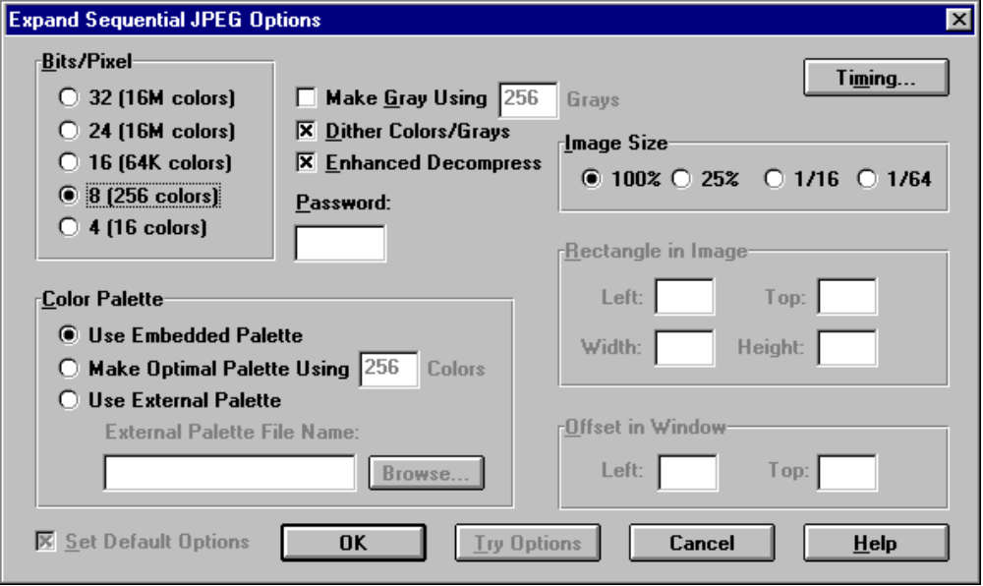

OpenProgressiveJpeg

Check boxes
Make Gray
Dither
Cross-block Smoothing
Radio buttons
Image Size: 1/64, 1/16, ¼, 1/1
DIB Bit Depth: 4, 8, 16, 24, 32
Progressive Display Style: Final DIB Only, Fuzzy-to-Clear
Final Color Palette: Use Embedded Palette, Make Optimal Palette, Use External Palette
Intermediate Scan Color Palette: Use Embedded Palette, Use Universal Palette, Use External Palette
Edit boxes
Key
Number of colors to make (defaults according to DIB Bit Depth
Scans to Decode
External Palette PIC/BMP File Name
Horizontal image offset to expand
Vertical image offset to expand
Wdith to expand
Height to expand
Horizontal DIB offset
Vertical DIB offset

If Fuzzy-to-Clear is specified, then at the end of each scan a dialog is displayed with the current scan number and the total number of scans (e.g. “Scan 2 of 4 is displayed.”). The dialog box has two push buttons. The first is labelled Next Scan. The second is labelled Full Detail.

OpenIM4

Radio buttons
DIB bit depth 4, 8, 16, 24

OpenIMStar

Check boxes:
Use Best Guess Interpolation
Radio buttons
Color Palette: Use Embedded Palette, Use External Palette
Layer Display Size: Display at Natural Layer Size, Zoom to Final Layer Size
Edit boxes
Final Layer to Expand
First Restart Region to Expand
Last Restart Region to Expand
Page Number to Expand
External Palette PIC/BMP File Name

OpenBMP (Opcode 81 not available)

No options.

OpenBMP (Opcode 81 available)

Check boxes
Make Gray
Dither
Radio buttons
Color Palette: Use Embedded Palette, Make Optimal Palette, Use External Palette
Edit boxes
External Palette PIC/BMP File Name
Number of colors to make (defaults according to DIB Bit Depth

OpenTGA

Check boxes
Make Gray
Dither
Radio buttons
Color Palette: Use Embedded Palette, Make Optimal Palette, Use External Palette
Edit boxes
External Palette PIC/BMP File Name
Number of colors to make (defaults according to DIB Bit Depth

OpenTIFF

Check boxes
Make Gray
Dither
Radio buttons
Color Palette: Use Embedded Palette, Make Optimal Palette, Use External Palette
Edit boxes
External Palette PIC/BMP File Name
Number of colors to make (defaults according to DIB Bit Depth

OpenPCX

Check boxes
Make Gray
Dither
Radio buttons
Color Palette: Use Embedded Palette, Make Optimal Palette, Use External Palette
Edit boxes
External Palette PIC/BMP File Name
Number of colors to make (defaults according to DIB Bit Depth

OpenGIF

Check boxes
Make Gray
Dither
Radio buttons
ProgressiveMode
Final DIB Only
Increasingly Larger DIBs
Same Size DIBs, Current Pass Only
Same Size DIBs, All Passes
Same Size DIBs, Smoothed, Current Pass Only
Same Size DIBs, Smoothed, All Passes
Color Palette: Use Embedded Palette, Make Optimal Palette, Use External Palette
Edit boxes
External Palette PIC/BMP File Name
Number of colors to make (defaults according to DIB Bit Depth

5. Save Opcodes

5.1 Save Opcodes Entry Points

Save Image

typedef BOOL (*PFNSAVE)(
const BYTE PICHUGE* pSrcImage,
DWORD dwSrcLen,
const PIC_PARM PICFAR* pSrcPicParm,
const BYTE PICHUGE* pDib,
DWORD dwDibLen,
const PIC_PARM PICFAR* pDibPicParm,
BYTE PICHUGE* PICFAR* ppSavedImage,
DWORD PICFAR* pdwSavedLen);

The function receives a pointer to a source file image buffer, the length of that data, and a pointer to the PegasusQuery PIC_PARM data returned for the source image. It also receives a pointer to the displayed DIB, the length of the DIB and a pointer to the PIC_PARM associated with the DIB. The function returns a pointer to a buffer contained a saved file image of the image and the length of the file image.
The function displays a Save Options dialog box. One option in this dialog allows the user to save from the source image or from the displayed DIB. If saving from the source image and a loss-less transformation is available between the source image format and the save opcode’s format, then that transformation is applied. If no transformation is available, then the source image is re-expanded to a DIB using options specific to this purpose and the resulting DIB is saved in the save opcode’s format.

Default Options Dialog

typedef void (*PFNVOIDPROCVOID)(void);

The Default Options dialog box is displayed. Default Options are read from and written to MINERVA.INI.

5.2 Save Options by Opcode
The selected file name filter on the common file dialog determines the save opcode to be used. The corresponding opcode’s save entry point in the save opcode table is used to create a saved file image of the image. Save will preserve comments, color maps and application data between source format and destination format to the maximum extent permitted by the respective opcode implementations so that the transformation from source to destination back to source doesn’t lose that data.

SaveSequentialJpeg

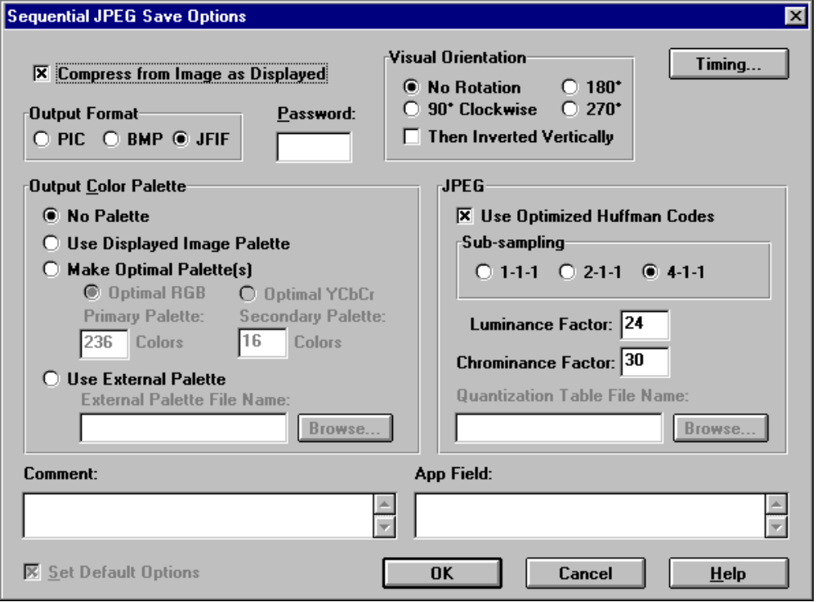

SaveProgressiveJpeg

Check boxes
Optimized Huffman
Visual Orientation Inverted
Radio buttons
Sub-sampling: 1-1-1, 2-1-1, 4-1-1
Visual Orientation: Normal, 90°, 180°, 270°
Edit boxes
Luminance factor
Chrominance factor
Quantization Table File Name
Progressive Script File Name
Application Data
Comment
Key

SaveIMStar

Check boxes
Visual Orientation Inverted
Radio buttons
Visual Orientation: Normal, 90°, 180°, 270°
Edit box
Application Data
Comment
Overlay Text
Page
Number of Pages
Number of Restart Regions
Transparent Color Index
User Delay
Horizontal Offset in DIB
Vertical Offset in DIB

SaveBMP

Edit box
Auxilliary Data

SaveTGA

Radio buttons
Output Bit Depth: 16, 24
Edit box
Comment

SaveTIFF

Edit box
Auxilliary Data

SavePCX

No options.

6. Transform Opcodes

6.1 Transform Opcodes Entry Points

Transform Image

typedef BOOL (*PFNTRANSFORM)(
HWND hWnd,
LPCSTR pszFilename,
BYTE PICHUGE* PICFAR* ppSrcImage,
DWORD PICFAR* pdwSrcLen,
PIC_PARM PICFAR* pSrcPicParm,
const BYTE PICHUGE* pDib,
DWORD dwDibLen,
const PIC_PARM PICFAR* pDibPicParm);

Receives a pointer to the window and filename so the transformed image can be re-opened into the window. It also receives pointers to the source image and source image PIC_PARM and to the DIB and DIB PIC_PARM. The source image pointer and PIC_PARM are replaced with the transformed source image.

Default Options Dialog

typedef void (*PFNVOIDPROCVOID)(void);

The Default Options dialog box is displayed. Default Options are read from and written to MINERVA.INI.

6.2 Transform Options by Opcode
Transformations are available from the Transform menu bar item The selected transformation is looked up in the transform opcode table by MMENU.C. The appropriate transformation opcode is then applied by calling the Transform entry point defined in that table entry.

TransformRotate

Check boxes
Keep Colors
Visual Orientation Inverted
Radio buttons
Visual Orientation: No rotation, 90°, 180°, 270°
Edit boxes
Key

If the source image type is not sequential JPEG, this option is not available.

TransformZoom

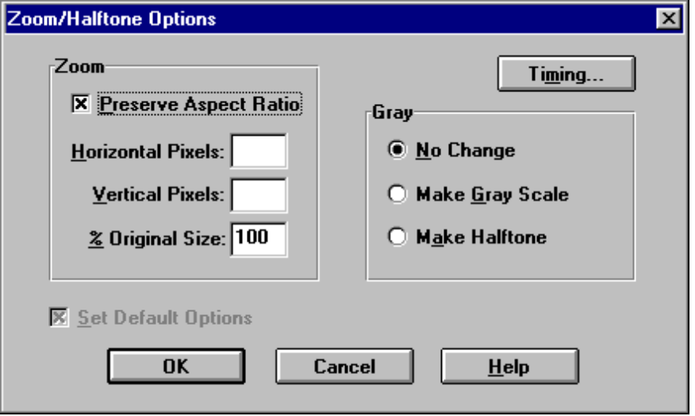

If the source DIB is not a 24-bit DIB or 8-bit gray scale DIB, this option is not available.

7. Tools Opcode

7.1 Tools Opcode Entry Point

Tool Entry Point

typedef void (*PFNVOIDPROCVOID)(void);
The only tool entry opcode currently is the color reduction utility opcode 82.

7.2 Tools Opcode Options

ToolsMakeOptimalPalette

This entry point presents the user with a dialog box containing a multiple select list box. The list box is initially empty. The user adds image files to the list by typing their names into an edit box above the list box or by pressing a Browse button and selecting one or multiple files from the common file open dialog box. Another edit box (and browse button) allows the user to select an output PIC or BMP file name to hold the created optimum palette. When the user presses OK, the palette is created and a message box tells the user that the palette file was successfully created.

